# SpringBoot Assessment

**Welcome to the course assessment for the Java & Spring Boot for Web Development module!**

In this session, you will complete a project about creating a Todo list.

By the end of this session, you will be able to:

● Build a full stack application using Java.

● Complete a Spring project.

Setup your spring project using **org.generation** as the company name.

Name your spring project as **todolist**.

You will develop a Simple Spring MVC Todo management web application using Spring Boot, Spring MVC, JPA and MySQL as a database.

1. Show all Todo list : Create a web page to display all Todo lists (the following UI is for illustration purposes. Feel free to do your own UI with the required information shown).

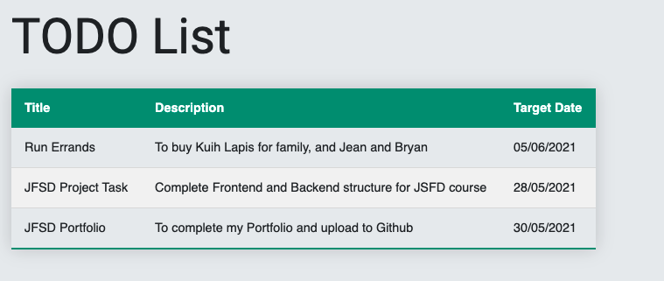

The table will list out all the information for the Todo list. Information to be retrieved from MySQL database.

1. Add Todo list: Create a web page to allow users to add their Todo list (the following UI is for illustration purposes. Feel free to do your own UI with the required information shown). Form should check for empty fields. Select of Target Date should be restricted to greater than today’s date.

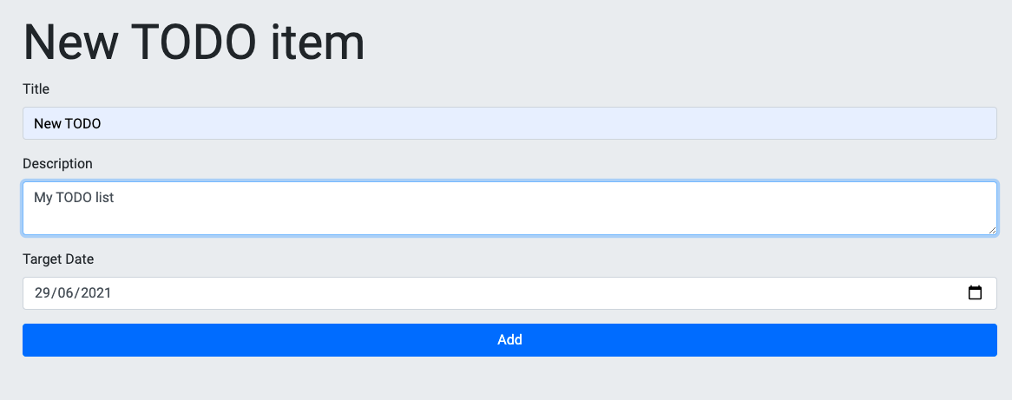

The form allows users to enter their Todo list details. When users click on the ‘Add’ button, the newly entered information will be added to the MySQL database.

1. Create a simple menu to navigate to the 2 pages (Show TODO list and Add TODO list). You can apply BootStrap with 2 basic links for the 2 pages. You may use the Thymeleaf package for URL routing and mapping.
2. Export your data to csv or json file and submit together with .mwb file and your project folder.

Please place your SpingBoot solution in your github

After completing it, make sure you come back to complete a reflection.

**Directions:**

● **Send** the link of your github repository to (set your repo name as todolist)

* [genfsd2021@gmail.com](mailto:genfsd2021@gmail.com)
* [awbingxian@gmail.com](mailto:awbingxian@gmail.com)

● **Reflect** on the following questions.

**Questions:**

● **What did you like about this project?**

● **What did you struggle with in this project?**

● **What would make your experience with this assessment better?**

**Deadline: 09 May 2023, 2359pm**

